# Mongo DB Installation Guide

Guide for downloading and installation of MongoDB on Windows for the ["MongoDB Course @ SoftUni”](https://softuni.bg/trainings/2811/mongo-db-february-2020).

# Download the MongoDB MSI Installer Package

Download the current version of MongoDB from [here](https://www.mongodb.com/download-center/community). Make sure you **select MSI** as the package you want to download:

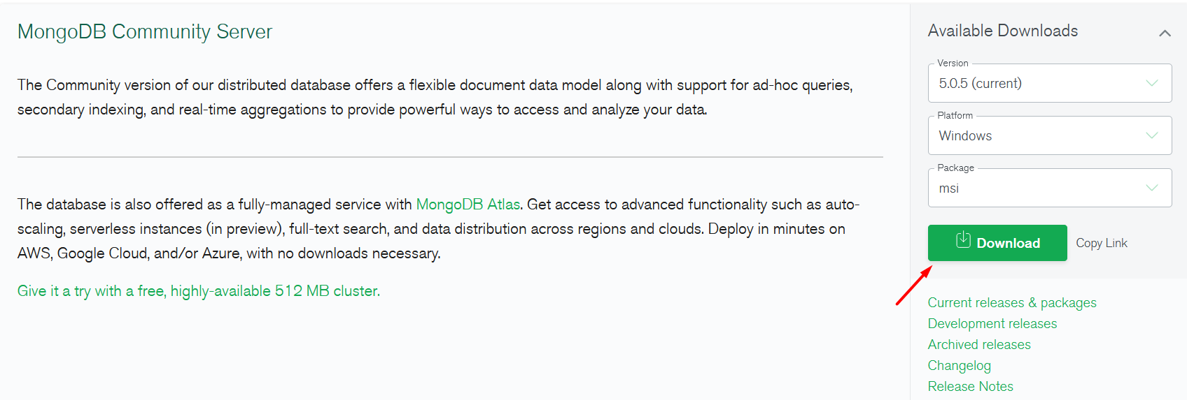

# Installing MongoDB 5.0.5

Navigate to your downloads folder and double click on the **.msi** package you just downloaded. This will launch the installation wizard.

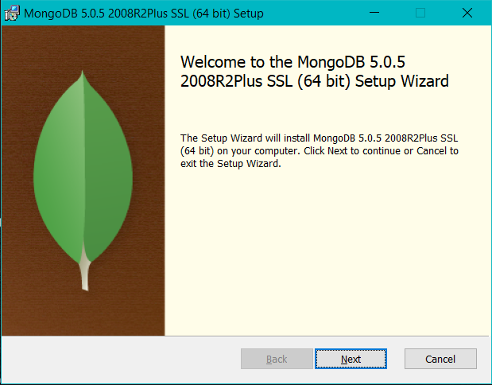

Click **Next**, then accept the license agreement and click **Next** again. Choose the **Complete** setup type:

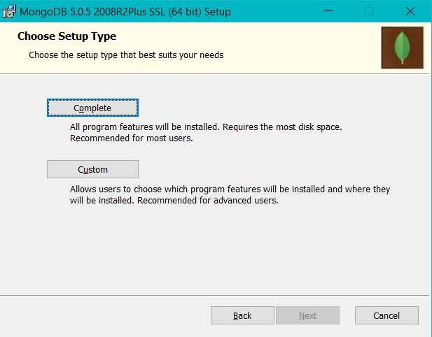

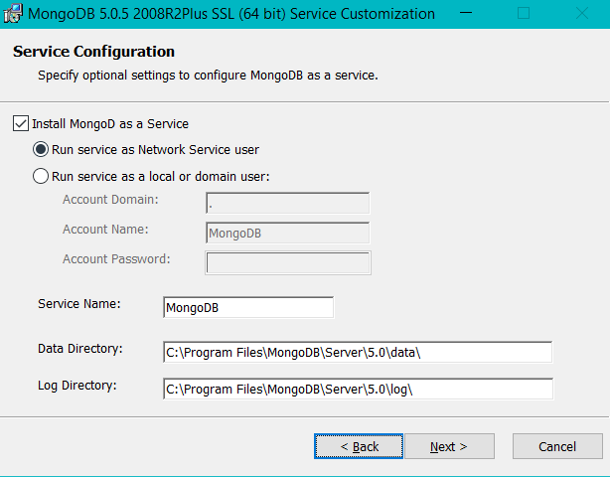

Here we stay with the default option **Install MongoDB as a Service** and **Run service as Network Service user**.

Then go through **Install** and **Finish** like this:

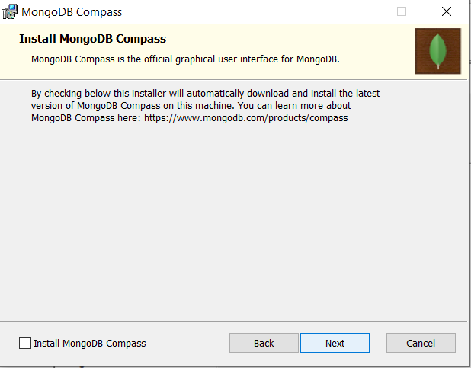 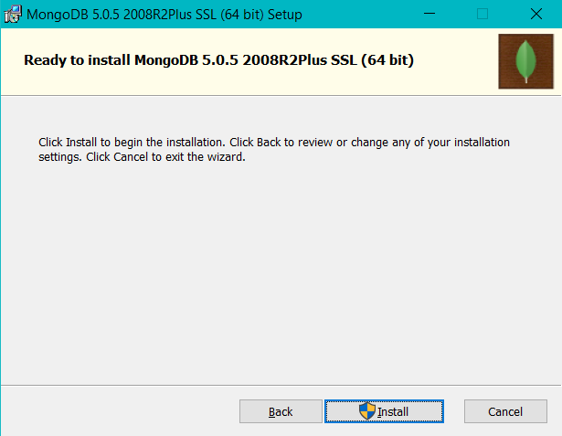

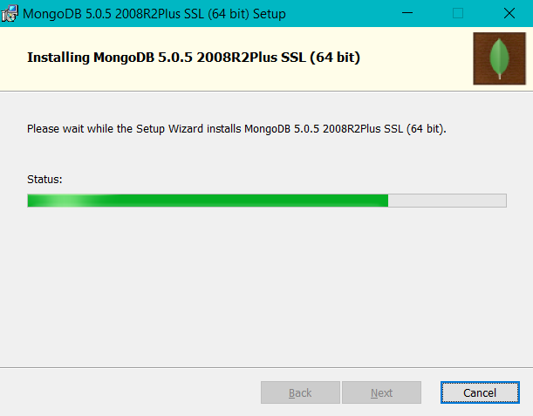 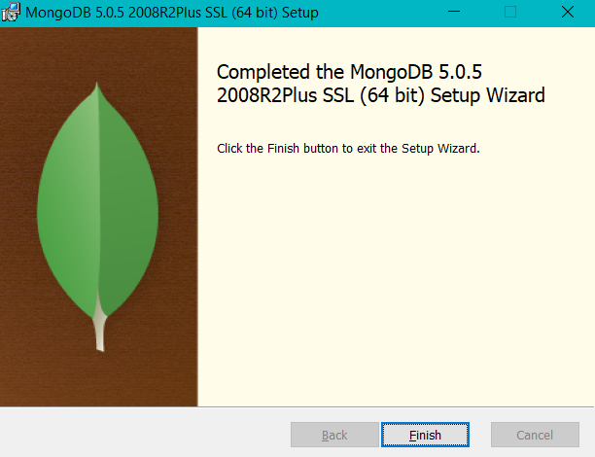

After finishing the installation you need to **restart** your system.

# Setups and test

Navigate to the installed MongoDB **bin** folder

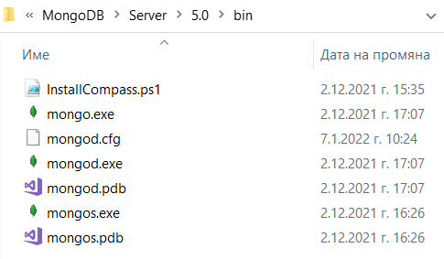

Open the folder in command prompt and run **>mongo** command.

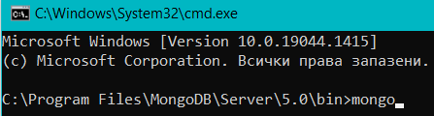

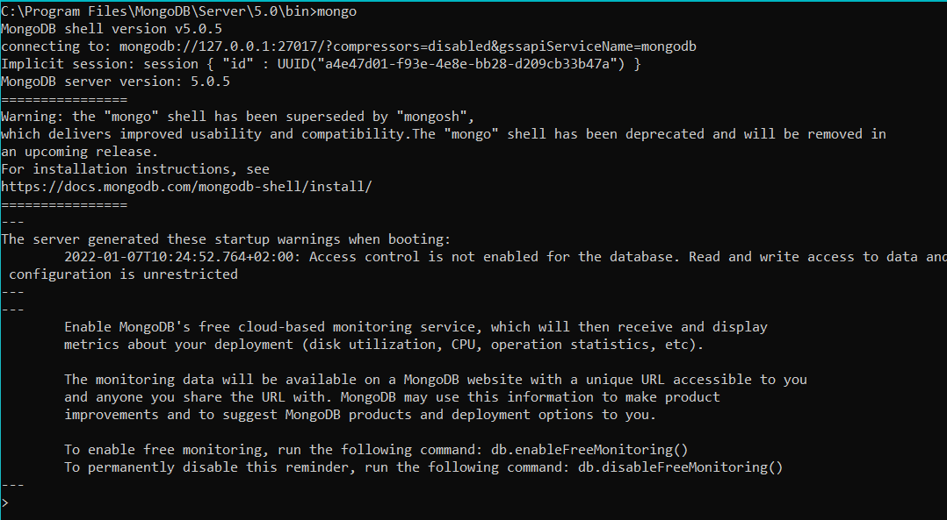

This will run the [**MongoDB shell**](https://docs.mongodb.com/manual/mongo/). You can use the mongo shell to query and update data as well as perform administrative operations. Here we can test and manually create a new database, add a collection to it.

To print a list of all databases on the server we use the **>show dbs** command.

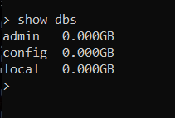

Creat new database by **> use <databaseName>**

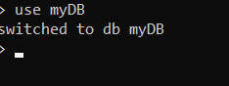

To see the new database with the show command we should first put the same data in it. We can create a new collection with a document using **> db.<collectionName>.insert(document)** . Example:



Now **> show dbs** will show us our new database:

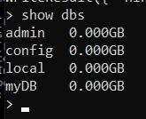

And **> show collections** will show us the new collection:

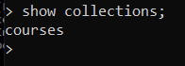

Executing **> db.collection.find()** in the mongo shell automatically iterates the cursor to display up to the first 20 documents if any.

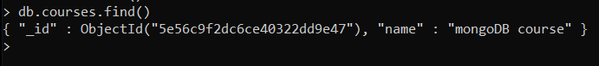

Now you have MongoDB installed, tested, and ready to work. More info read on [**The MongoDB 4.2 Manual.**](https://docs.mongodb.com/manual/mongo/)